How to register on the Local Food Coop website

Note: this document describes how to register on the Local Food Coop website. Once you have registered, an account will be created for you. You can then log in to the website to make orders – see the “How to make an order on the Local Food Coop website” document for more information. Read below to find out how to register.

Go to the registration form
Click the link below to open the registration form in your web browser:

http://localhost/foodcoop/shop/members/member_form.php

You should see a webpage like this:

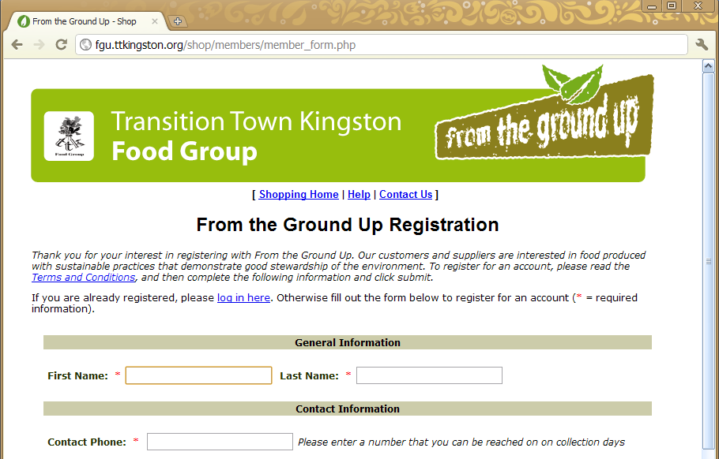

Fill in the registration form
Fill in the registration form. Boxes marked with a red asterisk (*) must be filled in. An example form is given below.
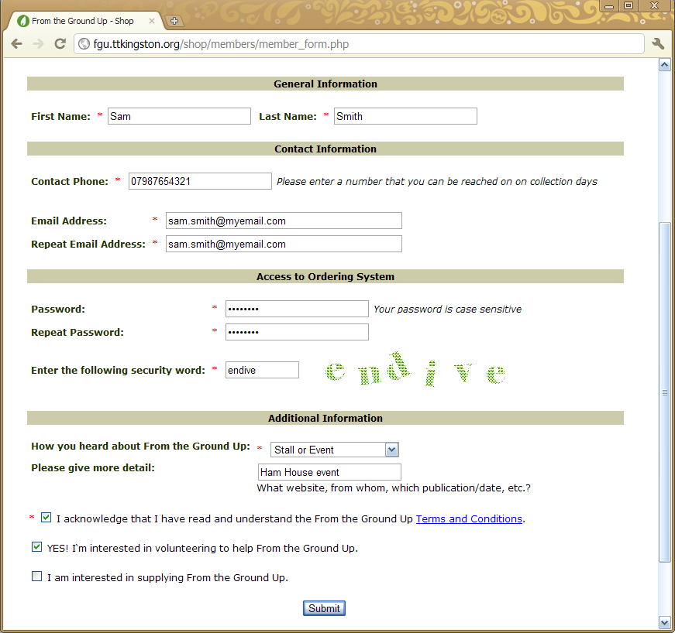

Submit the registration form
Once you have filled in the registration form, press the “Submit” button at the bottom:

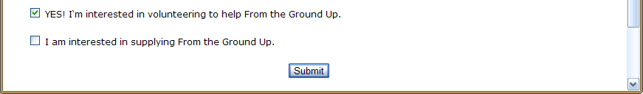

That’s it! Once you submit your registration form, you will receive a confirmation email.

